Katelin Shannon
Subject: Reading
Unit: Animals in their Habitat
Grade: 3rd

Summary of Unit:

In the Animal in their Habitat Unit, it will cover the various types of habitats, what animals live in those habitats and how they adapt to their habitats. The students will work a step-by-step process to create a final project that will include a research paper on a specific animal, and a poster that will include details about their animal. Students will gain background knowledge first on habitats and then learn about certain animals in the habitats. Students will use the 6 trait writing process. The students will interpret information on their own to then turn it into a multiple paragraph paper.

Unit Objectives:

Students will have the opportunity to create a deeper understanding of animals in their habitat by creating animal habitat flipbooks, researching animals through technology and book resources, and developing a final project on their animal. Students will be able to write a multi paragraph paper on their animal using the 6 writing traits and also a poster that will be presented in the class. They will also learn to use teamwork, as they will be working as partners on a specific animal that was chosen for them. There will be multiple guided practices but also activities that will be used as check points for their learning.

Student Objectives:

Skill:
- Students will be able to produce a multi paragraph informative text about an animal using technology and book resources. Write informative/explanatory texts to examine a topic and convey ideas and information clearly. (W.3. 2)
- Students will be able to use the 6 writing traits with guidance and support from adults and peers to develop and strengthen their writing. (W. 3. 4, W. 3. 5)
- Students will be able to produce and publish writing with the helps of their peers (W. 3. 6)
- Students will be able to write over an extended time period to for research, reflection, and revision. (W. 3. 10)
Demonstration:
- Students will be able to demonstrate their understanding of animals in their habitats by using graphic organizers to take notes by recalling information from media or books. (W. 3. 8)
Knowledge:
- Students will be able to understand and be able to demonstrate their understanding of animals in their habitats by discussion using a K-W-L through whole group and partner discussion (SL. 3.1)
- Students will be able to recognize animal adaptions by identifying certain animal characteristics that fit with the specific adaptation category. (RI.3.4)

Why are they studying this?
In the third grade students do a unit on Animals in their habitats because students must understand the different habitats that are around the world and what animals live in those habitats. Students need to understand that students have to adapt to their habitats and know how they can do so. Also, they are expected to write an informative text using multiple paragraphs. The students must also learn to collaborate with others to research and to use the correct writing methods. This unit will help students thinker deeper as they have to research, take notes, write, revise, edit and create a final copy of their animal research project.

Formative Assessment Number One
Animal Adaptions Quiz
SWBAT:
- Use previous knowledge to answer the questions about animal adaptations
- Use process of elimination as a test taking strategy
- Be able to use this information from this quiz in their research projects on animals
Accommodations:
- Students who finish early will either read a book silently or practice spelling words since this is our first introduction to animals
- LEP students will be able to get the quiz read to them
Standards:
- CCSS.ELA-Literacy.RI.3.4 Determine the meaning of general academic and domain-specific words and phrases in a text relevant to a grade 3 topic or subject area.
- CCSS.ELA-Literacy.RF.3.4 Read with sufficient accuracy and fluency to support comprehension.
Summary:
Students will be given this quiz at the beginning of Animals in Their Habitats Unit. It will give the students an introduction of what they will be working on and learning about. The adaptation quiz is a formative assessment because it allowed me to read over the quizzes and see which animal adaptations students were confused on or had to knowledge of what they were. I then would gather resources to be able to teach these students these adaptations along with reviewing those they may already be familiar with. Students need to have a strong understanding of animal adaptations so they can use the certain types in their animal projects as they research and write their expository text about their animal.

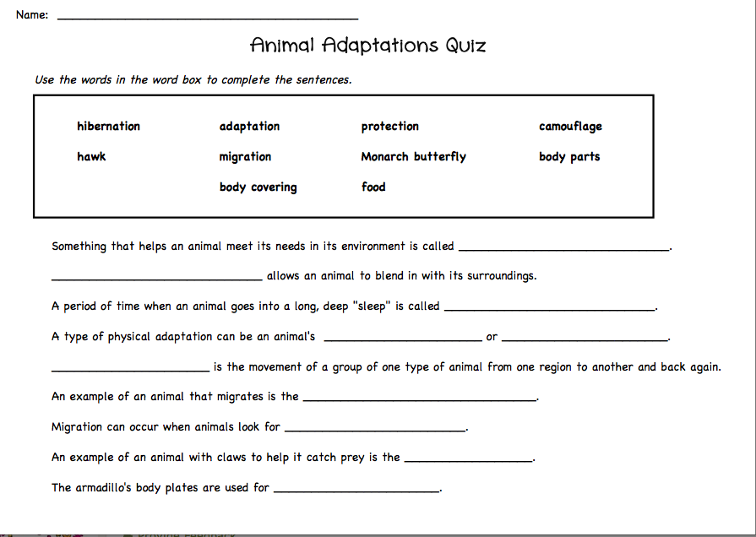

Formative Assessment Number Two
Animal Adaptations Cut and Paste
Activities and Assessments Prior to this Formal Assessment
- Animal Adaptations Quiz
- PPT with definitions of what adaptations are and other vocabulary
  - Behavioral Adaptations: Migration and Hibernation
  - Physical Adaptations: Body Parts, Body Covering, Color & Shape
  - Mimicry
  - Camouflage
- Focus to understand how animals survive in their habitats
- Camouflage Butterfly Activity: Students color a butterfly that will be camouflage in the classroom
SWBAT:
- Identify different types of animal adaptations
- Rearrange animal scenarios into adaptation categories based upon the descriptions
- Explain what different animal adaptations are to other student through partner teaching
- Use this information for their research on animals paper

Standards:
- CCSS.ELA-Literacy.RF.3.4c Use context to confirm or self-correct word recognition and understanding, rereading as necessary.
- CCSS.ELA-Literacy.RI.3.1 Ask and answer questions to demonstrate understanding of a text, referring explicitly to the text as the basis for the answers.

Summary of Assessment:
- This is a formative assessment because I am using it as a checkpoint to see if students are still misunderstanding of the key vocabulary words that they will need to know for their expository writing on their animal. They have been exposed to this information through a pre test and also through power point and other activities. This will be done independently and will be done a couple days after the activities are completed. By now I hope students are grasping these vocabulary words but if not then it gives a guide for further instruction to keep teaching these adaptations until students fully understand them and are able to recognize them to be able to match their animal to adaptations.

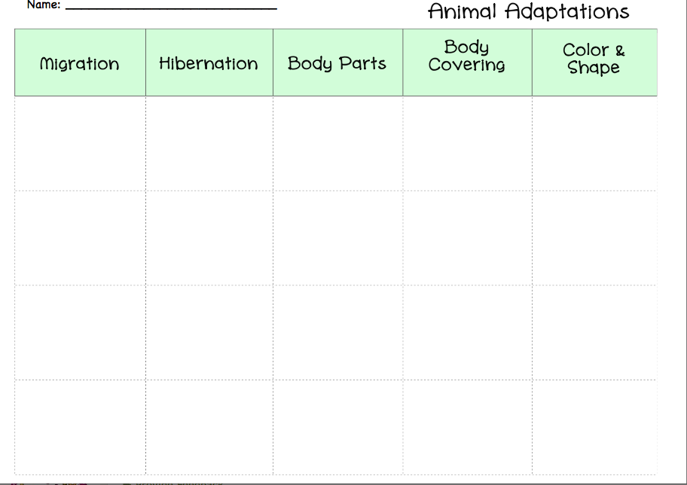
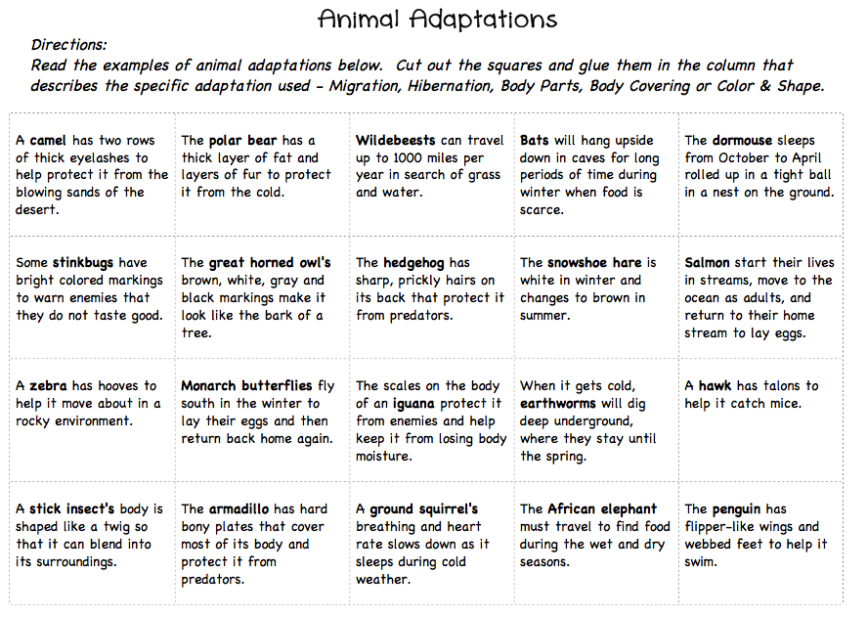
Formative Assessment Number Three
K-W-L
Assessments and Activities Leading up to the K-W-L
- Students will do an animal habitat flipbook that will ask three questions about the habitat. Each habitat will be a flip book of an animal that lives in that habitat
  - Where is the habitat located?
  - What animals and plants are found in this habitat?
  - What 3 interesting facts did you learn about this habitat?
6 Habitats: Artic Tundra, Grasslands, Forest, Tropical Rainforest, Desert, and Wetlands
- Partners will research on their assigned habitat on iPads, accessing one website
- After, students will answer the questions and put together their animal flipbook
- Then, students will share information to the classroom on each of the different habitats.
- Individually, students will create a K-W-L on habitats and animals using information from the quiz, and from the different habitats. This will be a form of note taking to help with their research on animals and habitats.
- Then, we will come together and do a class K-W-L chart together based off of their own.
- Turn in completed KWL Chart

SWBAT:
- Students will be able to use technology, iPads, to research their habitat and gain information
- Take notes using a flip book and also a KWL Chart
- Work in partners and also independently
- Turn in the KWL chart and Flip books
  - KWL chart will be graded by students having at least four ideas in the “W” and “L” sections after presentations on habitats, research, and flipbooks.
  - Leaning how to take effective notes for use

Accommodations:
- Students are paired together by students who struggle in class with students who are above level or who are more willing to help students out to succeed.
- Students who finish early with flip books or KWL will go around to other groups to help
- Students who don’t finish will be given time later in the day to finish; recess, specials, lunch, or end of the day.

Standards:
- CCSS.ELA-Literacy.RF.3.4 Read with sufficient accuracy and fluency to support comprehension.
- CCSS.ELA-Literacy.RF.3.4a Read grade-level text with purpose and understanding
- CCSS.ELA-Literacy.W.3.1a Introduce the topic or text they are writing about, state an opinion, and create an organizational structure that lists reasons.
- CCSS.ELA-Literacy.W.3.2 Write informative/explanatory texts to examine a topic and convey ideas and information clearly.
- CCSS.ELA-Literacy.SL.3.1a Come to discussions prepared, having read or studied required material; explicitly draw on that preparation and other information known about the topic to explore ideas under discussion.
- CCSS.ELA-Literacy.SL.3.1b Follow agreed-upon rules for discussions (e.g., gaining the floor in respectful ways, listening to others with care, speaking one at a time about the topics and texts under discussion).

Summary of Assessment:

Students will feel out the “K” part of the KWL Chart before they do their research on their animal flipbooks. Students will then research the habitat given to them, create their flip books, present, and then fill out the rest of KWL Chart. The KWL Chart is a formative assessment because it will allow me to see if students are gathering information and understanding animal habitats. I will look over each one individually to check for these components of their learning but also I will be formative assessing during group discussion over the class KWL Chart. This will give me a brief idea of what students are missing when it comes to the important facts about habitats and animals that they will need for their research project. This will give me direction on what I need to touch on as far as key points my students are missing for being able research.

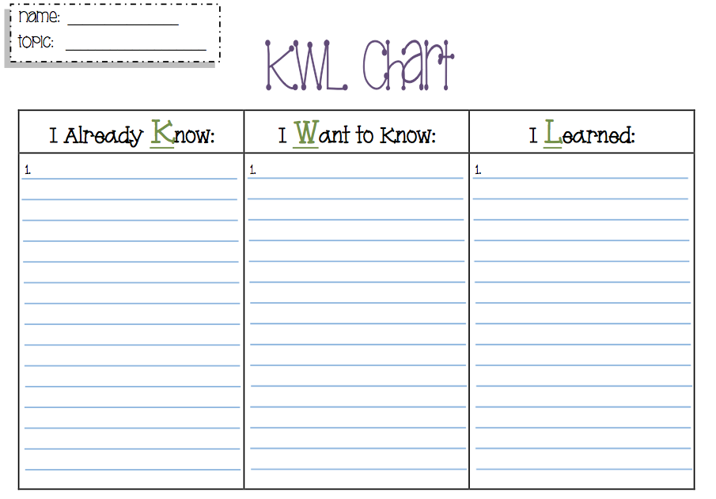

Formative Assessment Number Four
Graphic Organizer of Student’s Specific Animal
Activities and Assessments prior to Formative Assessment
- Animal Characteristic Task Cards
- Group discussion on how to gather facts and information from resources with out plagiarizing and putting them into their own words.
- How to read section headings to find information specific information that is needed.
- Students are partnered up and given a specific animal to research that lives in one of the habitats we discussed earlier (Animal Habitat Flip Books)
- Research and collect facts about their animal using iPads by accessing one website and using two books for resources

Accommodations:
- Students will be partnered up with one student be low and one student being a higher and being able to help
- Students who finish first will go back through their resources and see if they can any more information about their animal in the boxes. The more information they have the easier it will be for them to write their paragraphs.’
  - If they finish with that they may read an article or poem on animal habitats that will be provided for them
- Students who do not finish will have time to work on it the next day or during free time at the end of day

Standards:
- CCSS.ELA-Literacy.RF.3.4 Read with sufficient accuracy and fluency to support comprehension.
- CCSS.ELA-Literacy.RF.3.4a Read grade-level text with purpose and understanding
- CCSS.ELA-Literacy.W.3.1a Introduce the topic or text they are writing about, state an opinion, and create an organizational structure that lists reasons.
- CCSS.ELA-Literacy.W.3.2 Write informative/explanatory texts to examine a topic and convey ideas and information clearly.
- CCSS.ELA-Literacy.SL.3.1a Come to discussions prepared, having read or studied required material; explicitly draw on that preparation and other information known about the topic to explore ideas under discussion.

Summary of Assessment:
The graphic organizer is used as a formative assessment during this unit because it will show me if students understand the certain categories they are suppose to be taking notes on and if they writing down the important facts needed to write their paragraphs. Also, students need to have at least four or five facts listed in each box so that they can write an effective three-paragraph paper. This will also show me if they are good at categorizing information. This organizer will show the students and me if they may need to go back and research more on their animal or if they need more clarification on the categories.

- 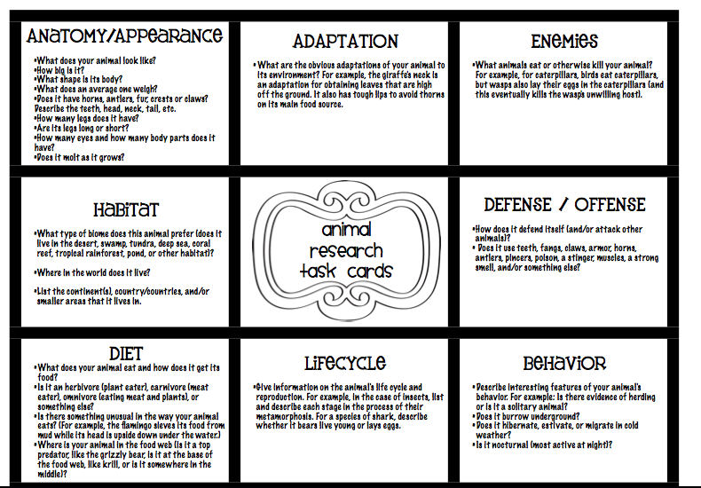

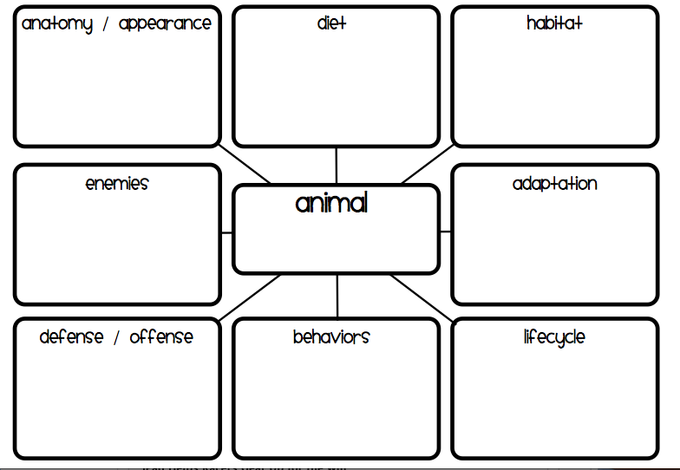
Formative Assessment Number Five
Rough Draft of a three paragraph expository text on specific animal
Activities and Assessments prior to Rough Draft and during
- Graphic organizer to look back on
- Research of animal using resources
- Background information from previous activities and assessments
- Can use their KWL Chart about habitats
- Writing a three paragraph rough draft expository essay on their specific animal’s adaptations, appearance, and habitat
- Personal revision, peer revision, personal editing, peer editing
- Discuss rubric to help students work on creating a better essay for the final draft
- Turn in rough draft for rubric check and conferences

SWBAT:
- Write a three paragraph paper about an animal’s adaptations, appearance, and habitat
- Revise and edit independently and with peers to develop quality writing
- Collaborate with teacher about the rough draft and rubric
- Use the 6 writing traits

Accommodations:
- For students who finish, they may write an extra paragraph about an interesting fact about their animal that other people may not know.
  - If students finish the extra paragraph and have edited their paper they may help other people revise and edit their paper.
- For students who did not finish, they will have a few days to work on their rough drafts
  - If there are students who strongly struggle with writing then they may only do two paragraphs but still will have to revise and edit independently and with peers.

Standards:
- CCSS.ELA-Literacy.RI.3.1 Ask and answer questions to demonstrate understanding of a text, referring explicitly to the text as the basis for the answers.
- CCSS.ELA-Literacy.RI.3.2 Determine the main idea of a text; recount the key details and explain how they support the main idea.
- CCSS.ELA-Literacy.RI.3.7 Use information gained from illustrations (e.g., maps, photographs) and the words in a text to demonstrate understanding of the text (e.g., where, when, why, and how key events occur).
- CCSS.ELA-Literacy.W.3.2 Write informative/explanatory texts to examine a topic and convey ideas and information clearly.
- CCSS.ELA-Literacy.W.3.2b Develop the topic with facts, definitions, and details.
- CCSS.ELA-Literacy.W.3.2c Use linking words and phrases (e.g., also, another, and, more, but) to connect ideas within categories of information.
- CCSS.ELA-Literacy.W.3.2d Provide a concluding statement or section.
- CCSS.ELA-Literacy.W.3.5 With guidance and support from peers and adults, develop and strengthen writing as needed by planning, revising, and editing.
- CCSS.ELA-Literacy.W.3.7 Conduct short research projects that build knowledge about a topic.
- CCSS.ELA-Literacy.W.3.8 Recall information from experiences or gather information from print and digital sources; take brief notes on sources and sort evidence into provided categories.
- CCSS.ELA-Literacy.W.3.10 Write routinely over extended time frames (time for research, reflection, and revision) and shorter time frames (a single sitting or a day or two) for a range of discipline-specific tasks, purposes, and audiences.
- CCSS.ELA-Literacy.L.3 Demonstrate command of the conventions of standard English grammar and usage when writing or speaking.
- CCSS.ELA-Literacy.L.3.2 Demonstrate command of the conventions of standard English capitalization, punctuation, and spelling when writing.
Summary of Assessment:
Students will be asked to write a rough draft using three or four paragraphs that will about the animal’s appearance, adaptations, and habitat. The students who finished early will write a fourth paragraph about an interesting fact. Students will use their KWL Chart and their animal research graphic organizer to complete these paragraphs. Students will need to only use these resources for their essay. After students have completed their rough draft, they will use the 6 writing traits to enhance their writing. They must revise and edit independently and then with a peer. Once they have completed those two steps, they will come to me and we will fill out a rubric together to show what they need to improve the quality of writing. This will be a way to help students assess their own writing and for me as well to see where some misconceptions are or what they are doing great on. They will then go back and work on their writing some more to start creating their final. The rubric will be the same rubric used on their final draft.
Rubric for rough draft and final:
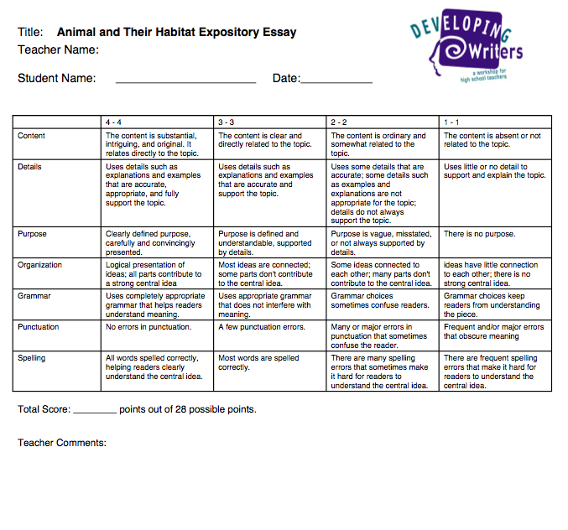

Summative Assessment
Final Draft of three paragraph expository essay on specific animal
Activities and Assessments
- 6 Trait Writing
- Illustration of animal
- Written Final Copy and then a typed final copy
- Graded Rubric
SWBAT:
- Explain their animal’s appearance, adaptations, and habitats in three paragraphs using appropriate grammar skills and display appropriate knowledge formulated by research and graphic organizers to show understanding
- Type their final copy
- Illustrate a picture of their animal (Not graded)
- Have a meeting with teacher to go over grade with the rubric present
Accommodations:
- Students who finish early will work on an illustration of their animal and the be able to share their essay with other students who have finished.
- Students will have a few days to work on final draft and will be able to finish. If they don’t finish during class time, they will work during recess on it.
Standards:
- CCSS.ELA-Literacy.W.3.7 Conduct short research projects that build knowledge about a topic.
- CCSS.ELA-Literacy.L.3 Demonstrate command of the conventions of standard English grammar and usage when writing or speaking.
- CCSS.ELA-Literacy.L.3.2 Demonstrate command of the conventions of standard English capitalization, punctuation, and spelling when writing.
- CCSS.ELA-Literacy.W.3.2 Write informative/explanatory texts to examine a topic and convey ideas and information clearly.
- CCSS.ELA-Literacy.W.3.6 With guidance and support from adults, use technology to produce and publish writing (using keyboarding skills) as well as to interact and collaborate with others.

Summary of Assessment:
- This will be the summative assessment for my students. During this unit, I will use formative assessments as check points to make sure my student are on the right track so they are able to gain knowledge and produce information to write a quality essay on animal and their habitats. They will type their final draft to make it look professional and will be graded using the rubric. Students will also include an illustration of their animal in their habitat but will not be graded on this. Once they have turned in their final copy, I will use the same rubric as they rough draft so they know what is expected of them to grade it. After, I will meet with each student and go over their paper including their rough draft rubric and final draft rubric to see the improvement or maybe even lack off, lets hope that’s not the case. This summative assessment will wrap off all of the components learned throughout the unit. Students will have to include adaptations, and habitats in their paper and explain how animals survive by using adaptations. This gives me a look at if they understood those key terms or maybe still were confused at the end of the unit.

Rubric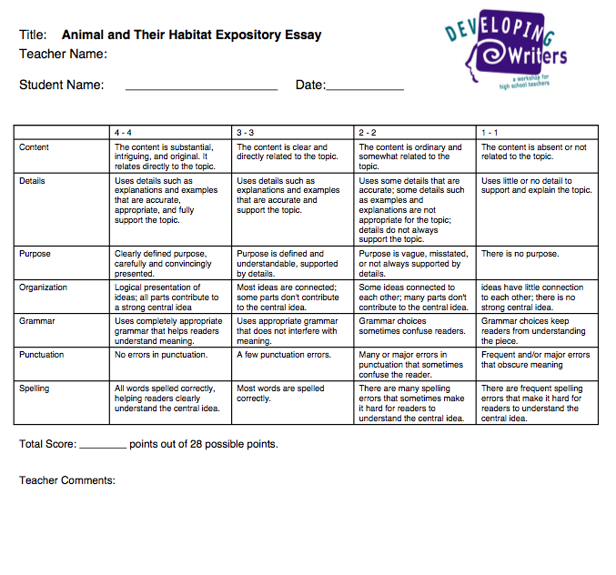

Feedback and Revision:
- During this entire unit, I will continuously be giving feedback to my students about their assessments they were given throughout the unit. I will provide feedback by conferencing with students, or handing back sticky notes on papers that may include areas they need to work on or areas they are doing great on to help put some positivity into them. Then students may add to their assessments to increase their knowledge of the topic. I will make a copy of all my notes to students so then at the end of the unit and with the summative assessment, I can conference with my students about how the formative assessments helped with the summative assessment.

Mastery of Skill:
The students must do the following:
- Show a clearing understanding of the different adaptations of animals
- Construct a three-paragraph essay with a score of 20/28 or above showing a clear understanding and purpose of their writing.
- Show revision and editing skills to improve their writing

Converting Grades to the Grade Book:
- With the rubrics included in my unit, students are graded on their essay with the highest score being 28/28. I will calculate that out into percentage and put it into the grade book.

Reflection to Creating the Formative Assessments

This process of creating formative assessments was pretty difficult for me. The reason being is because I had a hard time differentiating between activities and formative assessments. As I kept brainstorming different assessments to have, I would always reconsider using them because they could also be activities. So, I went back to my book and notes used for this class and reviewed what a formative assessment could be, which then made me realize that as long as I could explain how I can use it as a formative assessment then it could be one. It’s a tricky concept to understand sometimes when creating them.
During creating this formative assessment project, I realized what a long process it is. It’s definitely not a wham-bam it’s down kind of thing, it takes time to think, process, create, edit, think some more, and then put the finishing touches to it. This process helped me as a soon to be teacher because I realize the importance that formative assessments can have when creating a unit. Formative assessments lead up to your summative assessments and teachers and students need them as a checking point to see where they are.
Overall, this was a good learning experience for me and was a good finishing touch to end this class. It brought together every thing we had learned through out the semester. I learned a lot from actually doing and creating formative assessments through this assignment.

