Motivation in the Classroom Aimed for Individual Success
Katelin Shannon

A student with his head down on his desk, arms covering his head, and a math worksheet crumpled on the ground. As, I walk over to see what’s wrong, I feel myself preparing for a battle that I have already fought several times, and at least that’s what it felt like. I get to Sam and ask him, “ What’s wrong Sam?” “ I’m stupid, I don’t understand anything, and I’m just dumb!”
As a teacher, that is just heartbreaking to hear from one of my students. I was determined to change and help Sam become more positive and gain confidence in him. I didn’t want him to continue receiving failing grades for not completing his work. I was determined to make him see and know he could succeed.
First time seeing this behavior from Sam (not the kid’s name) was on my first day of student teaching at this school. He didn’t want to do a test that was given to the whole class, so he told the teacher he was not smart and didn’t know any of the answers. Her response was, “Well, then turn it in and you will be receiving a zero.” This didn’t even seem to faze Sam at all; he flat out didn’t seem to care, not a single answer was written down on the paper. There was another zero for Sam. During a break, I asked the teacher about Sam and asked why he does this. She said, “ That at home he just gets away with throwing a fit and saying he isn’t smart so that he gets out of doing his homework or something else he may not want to do.” My lead teacher also mentioned that she thinks Sam’s behavior seems to have become a learned behavior and that it is an everyday struggle at some point during the day. After observing Sam, I saw his lack of motivation and I realized that I needed to find strategies that would help Sam get motivated about school. I was drawn to Sam from the beginning and wanted to see him be successful in the classroom. The question was now how?
What is Student Motivation?
According to Bomia, student motivation “refers to a student’s willingness, need, desire and compulsion to participate in, and be successful in, the learning process.” (Bomia, 1997, p.1) I also believe that along with what Bomia stated about student motivation, that it also consists of students applying them in their schoolwork when given the opportunity and exert a high level of effort and concentration in their own learning. Students are for the most part positive about their learning and show enthusiasm, interest, and curiosity. For example, students who are participating in discussions, asking questions when searching for answers to gain more knowledge or when they don’t understand the concept being taught, and take pride in their work are all ways I can tell when my students are self motivated. For those students who are less motivated or disengaged, “ are passive, do not put forth the effort, and give up easily in the face of challenges.” (Skinner & Belmont, p.4)
Two Types of Motivation: Separately or Together?
There are two types of ways in which people can be motivated, extrinsic motivation and intrinsic motivation. In my classroom, I have seen a mixture of both in my students and in Sam; I have mainly seen him be motivated by extrinsic motivation.
A student who is extrinsically motivated shows that she is engaged in learning “purely for the sake of attaining a reward or for avoiding some punishment.” (Dev, 1997) In the classroom, a teacher praising students in a positive way for academic achievement; handing out stickers on work to show they did a great job on the assignment, or rewarding students with candy or other rewards shows this shows how extrinsic motivation can be done in the classroom. When dealing with extrinsic motivation in the way of avoiding punishment, this can include, taking away recess, fun Friday, parties, or activities for students based upon academic performance.
Intrinsic motivation is when a student is motivated from within: Intrinsically motivated students actively engage themselves in learning out of curiosity, interest, or enjoyment, or in order to achieve their own intellectual and personal goals. (Brewester, p.8) Dev says, “A student who is intrinsically motivated… will not need any type of reward or incentive or initiate or complete a task. This type of student is more likely to complete the chosen task and be excited by the challenging nature of an activity.” (Dev. P.13)
During my research, I also found that some researchers don’t agree with students just being intrinsic or extrinsic motivated but instead a little bit of both. Sternberg and Lubart say that, “It is too simple to reflect the many complex and interrelated factors that influence students’ motivation to succeed in school.” They point out that the most successful students are motivated by both internal and external factors, and suggest that educators build on both types when working to engage students more fully in school. (Strong, Silver, & Robinson, 1995)
As I researched more on incorporating both intrinsic and extrinsic motivational tools into my teaching to help Sam out with his own motivation and to try and get him to be more intrinsically motivated so that he could be successful on his own, I came upon this list of the qualities that intrinsically motivated students portray.
Information was found from (Brewester & Frager p. 9)
- Earn higher grades and achievement test scores, on average, than extrinsically motivated students.
- Employ “strategies that demand more effort and that enable them to process information more deeply”
- Are more likely to feel confident about their ability to learn new material
- Are more likely to engage in “tasks that are moderately challenging, whereas extrinsically oriented students gravitate toward tasks that are low in degree of difficulty”
- Are more likely to persist with and complete assigned tasks
- Retain information and concepts longer, and are less likely to need remedial courses and review
- Are more likely to be lifelong learners, continuing to educate themselves outside the formal school setting long after external motivators such as grades and diplomas are removed
After looking at the positives of being an intrinsically motivated student, I knew this is where I wanted to help Sam aim to become over time. I want Sam to be a life long learner and to see that he has it in him to be successful.
One consistent way of trying to get Sam motivated during school was to always instill hope in him. Mendler urges that, “ There’s no reason to be motivated unless the student is hopeful that this particular class is somehow going to improve his or her life; that coming to this school is better than not coming; that coming here and performing, producing, and behaving is better than coming here and wasting time pushing other people’s buttons and doing nothing.” (Mendler, 2000)
One example of how I tried to instill hope with Sam, was that when he received a 30% on a math test, which was a failing grade,I gave the test back and gave him specific feedback on his misconceptions. We talked our way through the ones he got correct and I provided positive feedback to him and then I let him lead me through the ones he got wrong. This allowed him to discuss with me where he was struggling and how he was going to fix his answers. I allowed him to redo his work for a better grade. I wanted him to feel that “hope” that he can perform and produce. I not only did this process with Sam but with all my students.
Along with instilling hope in students to create motivation, I also found some more wonderful ways to do this with all my students in my classroom, not just specifically with Sam. I started using all these strategies and suggestions that I found within my research time and continue to use these with my student teaching and will with my own class. I believe that I am continuing to grow as a teacher and need to apply these to help my students be successful in their learning. Along with these strategies and suggestions, I came upon an article where Mendler talks about the five key ways to motivate students, which are:
Show students how achievement benefits life.
Tell students that getting good grades, working well, and making an effort do lead to fulfillment in adult life, whether that means going to college, getting a decent job, or buying a house, and so on. Even if students don't buy into it, the notion will be planted and they will think about it. (Mendler, 2000) Also Michelle Wise Capen, an elementary teacher, says, “Tell your kids why you’re doing what you’re doing, especially if you’re assigning something repetitious and tedious. Even in kindergarten—a child will work harder at his handwriting if you sit down and tell him he’s building up his finger muscle strength. Make sure they understand you’re not just bossing them around.” (Wherry, 2005)
Create challenges that students can master.
Give students incremental challenges. For example, for the student who chronically doesn't do homework, Mendler suggests you ask her to do one problem for the next day, saying that you're going to call on her for the answer. Between 90 and 95 percent of typically unmotivated students will at least prepare that one problem. Students who lack motivation have been so accustomed to thinking that they can't be successful, that they have to be given small opportunities so they "may be reawakened" to the fact that they can be successful. (Mendler, 2000)
Focus on the teaching and learning process.
Be aware of the characteristics of a task that can be motivational elements. For example, is there enough time for the task? Can the student be successful at it? Is there some novelty to it? Are students sure of the purpose of it? Should it be done by oneself or with a partner? (Mendler, 2000)
Establish relationships.
If you invest enough chips in your "goodwill account" with certain students, you can make a "withdrawal" for which you demand better behavior, more academic effort, and so on. (Mendler, 2000)
Give rewards for an immediate gain.
Use this strategy to obtain a quick change in behavior. (Mendler, 2000)

Steps to Increasing Motivation in Sam:
Strategy One: Sticky Notes
Questions: Will motivating Sam using an extrinsic motivation strategy help him be successful? Will his motivation in school increase or will it just stay the same?
The Sticky Note incentive was suggested by our counselor from a class she had attended dealing with behaviors and motivation.
Length of Time Used: One and half weeks
The first strategy I used for Sam to promote positive behavior and to stay positive during work was to place a sticky note on his desk. Every time I saw him putting forth effort, participating in whole class discussion or group discussions, I would give him a tally. For when I saw that he was putting forth effort during individual assignments, I would give him two tally marks so that he saw that I noticed how well he was doing and he would feel satisfaction of doing well. At the end of the day, we would together count the total number of tallies. I would praise him on his good work for the day and tell him how proud of him for his effort and positive behavior.
If we had days where he didn’t receive very many tally marks we would have a discussion and talk about why he didn’t and how we, together, could improve the next day. These conversations usually took place the last ten minutes of the day. I always ended our conversation on a good note and so for the days that he has very little tally marks, I would still point out the times of the day where he was working hard and showing great behavior. I wanted him to still feel successful.
Conversation Notes:
My questions:
How did you feel about today?
What areas during the day can you improve on in order to have a better day tomorrow and be an active member in class?
How can I support you during the day to help you be successful?
Sam’s Responses: (Some days better than others)
- I can improve on working with my group and not getting frustrated by asking for help if I don’t understand something
- I can answer more questions when we have discussions
- Today was an okay day
- I tried during activities most of the time
- I’m stupid, I’m dumb, I’m never going to pass 5th grade
- I hate school, I don’t care
- If I need help, I need you to help me with it.
I would spend the last twenty minutes of the day helping Sam with any work he may need help with since my lead teacher would wrap up the day with the students.
This strategy lasted for about a week and half. The post it notes became more of a distraction than a positive note for Sam. He would draw on it or rip them up if he had one of his moments of feeling unconfident in himself. I could tell the excitement of the post it notes had worn off and his moments were becoming more frequent again during the day. Sam would just put his head down and not work at all or he would crumple up his work. He would no longer cooperate with his team when we would have group work or discussions. He took himself out of school and learning. It was back to him just quitting and not putting any more effort towards his work. Back to the drawing board because I was determined not to let him fail.
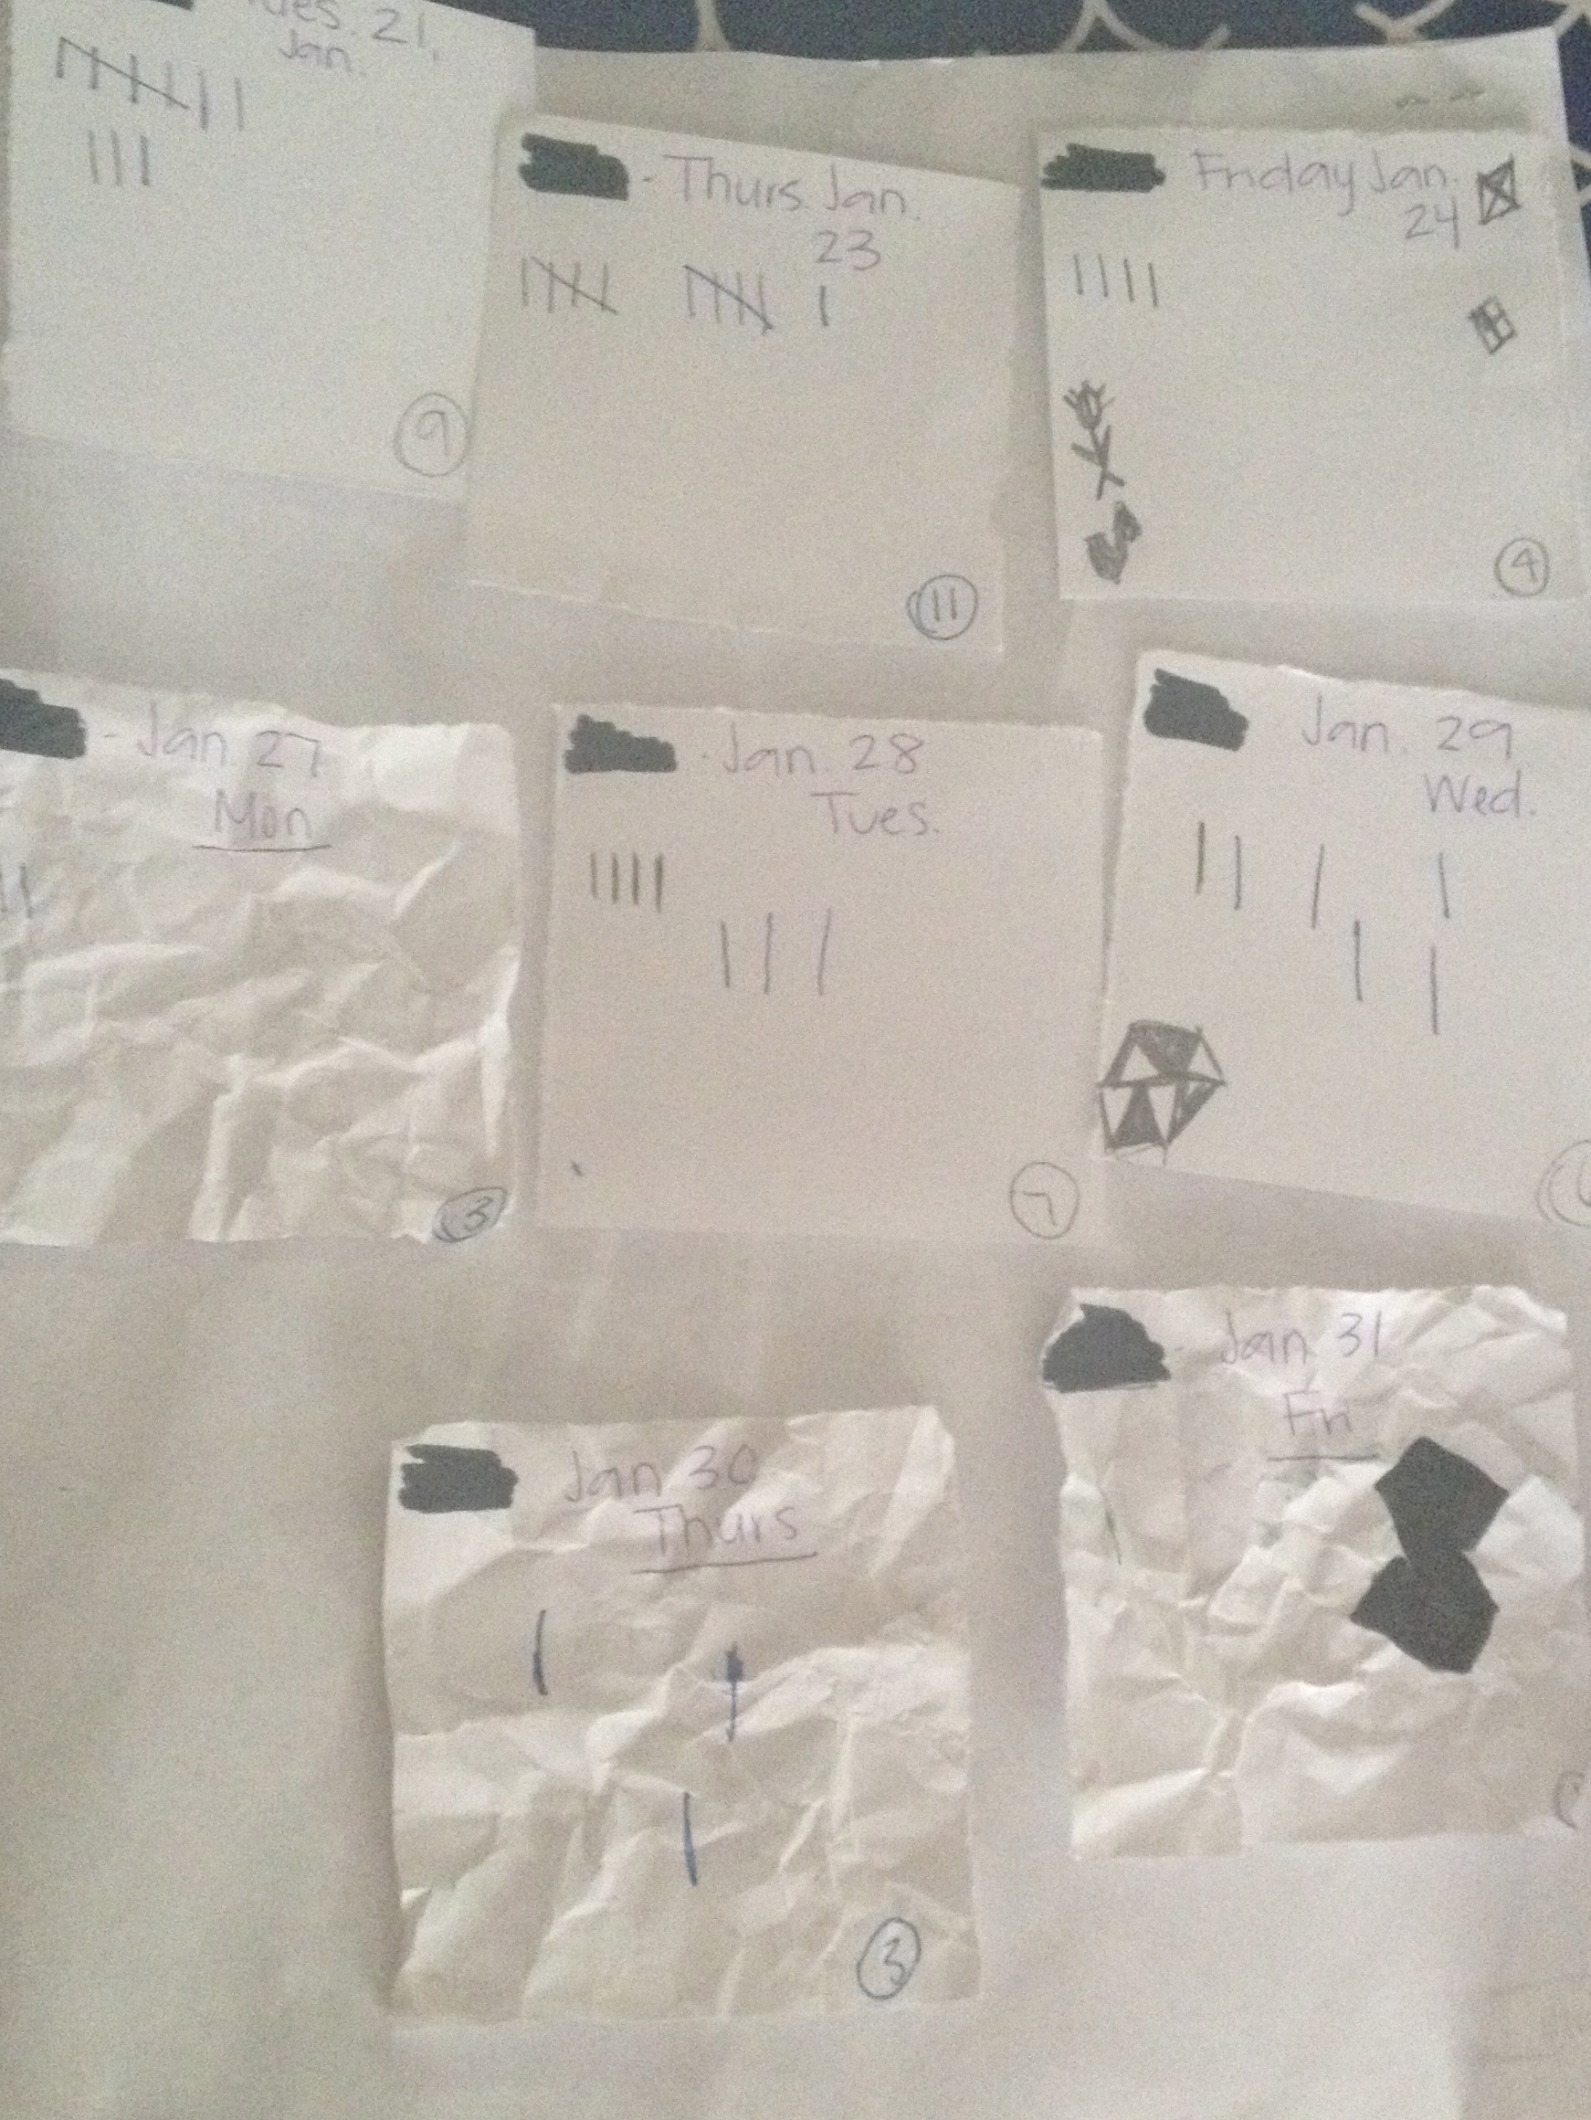

Plan Number Two: Dividing his tasks into small sections
Questions:
- Will breaking larger assignments into smaller tasks, help Sam feel successful when he is able to complete those tasks?
- When Sam completes those tasks, will he gain more motivation to complete further assignments on his own without as much help?
Time Used: Four weeks
The next strategy I used with Sam was that if Sam would begin to quit on his work, I would go up to him and ask him to do one problem for me at a time, which I received from How to Get Your Kids to Learn. (Jehlen, 2007) Also, Lumsden talks about breaking large tasks into smaller tasks and goals. Doing this prevents students from becoming overwhelmed. (Lumsden, 1994)
By the time, I walked around the room to help others; I expected it to be complete. For example, we were working on writing sentences that had to include a noun, verb, adverb, and a prepositional phrase. I gave the students the noun and verb, with the main focus of the assignment being adding an adverb. We had done a group activity to review what an adverb was and now it was time to check who understood adverbs individually.
For sentence number one, Sam said it was too hard for him even though I saw understanding from him during the whole group session. I could see that Sam understood the material because I would walk from group to group monitoring and he was writing down words and phrases that match the part speech given to his group. He had no trouble with coming up with the correct words and was discussing it with his team. I made it a point to create the sense of understanding in him and to encourage him. So I walked over to him asked what he was confused about and then explained to him what the purpose of the assignment was and what an adverb was. I gave him another example to clarify. I then told him that by the time I walked around the classroom, I wanted to see the first sentence completed. By the time I had walked around, Sam had completed two sentences! I would continue this with him, encouraging him more and more for the allotted time.
There were days and assignments that this would work for and I would see completed work from him. If Sam was really interested in that specific assignment we were doing, he was more than willing to do the assignment. Sometimes Sam would come to school with a sad attitude and just was not ready for the day and these would be the days we would struggle together to complete his work. I was able to get to know Sam, that I could tell what kind of day we would have, when I would say hello to him in the morning. During those days, when he was really having an off day from the beginning of the day, he would just completely shut down and this plan of action wouldn’t work. When Sam shut down, he would again put his head on his desk, not looking at anyone, or doing anything. He would just tell me over and over again, “That he was not smart and was never going to learn anything because he couldn’t.” With this being a plan where sometimes it wouldn’t and sometimes it would, I still wanted to find something that could really help him achieve success because he was a very capable student. I continued to use this plan with him for the rest of the time, because it was effective most times.
Example of Sam’s work during this step: I would use this strategy with him and he was able to be successful and finish his work. I praised him with positive comments and he felt very proud and accomplished for completing this assignment. 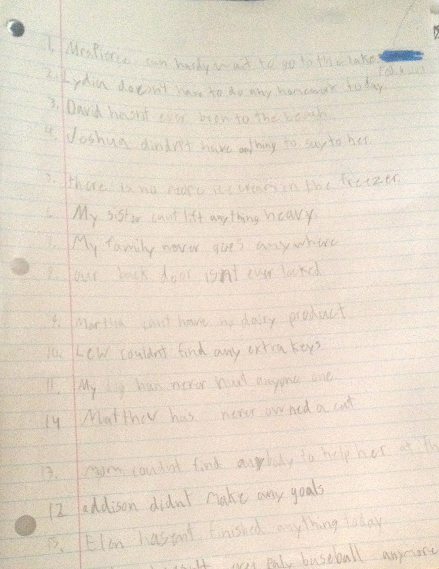
Example of a math assignment that Sam tried for most of the time and then came to a problem that he struggled with and shut down and quit trying.

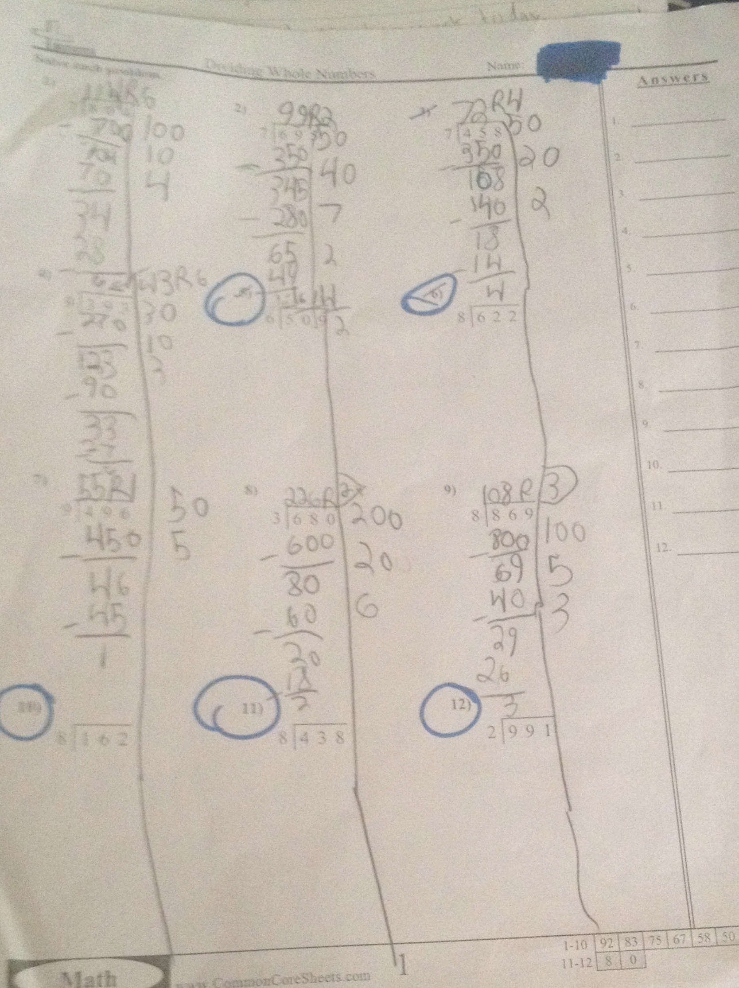

The Last Plan: Building a stronger relationship and finding Sam’s interest
Questions:
- Will using extrinsic motivation help Sam become motivated in his work?
- Will building a stronger relationship and finding out Sam’s interest help Sam become motivated knowing that he has a reward waiting for him?
Length of Time Used: Two weeks
The final plan I was able to try, I decided to try was to find interesting topics that Sam might like. Lumsden says, “That students need to feel welcome and supported.” (Lumsden, 1994). Elementary school students in particular need to feel that teachers are involved in their lives. Take time to get to know students, talk to them individually, and “express enjoyment in [your] interactions” (Skinner & Belmont, 1991). Also with this, I used extrinsic motivation, which I talked about earlier. Finding this research on how to motivate Sam, I thought talking to him and finding out his interests would be a great tool to use. This might be a good way to motivate him into wanted to complete his work without it being a struggle every time he thought something was too hard or just didn’t want to do it. So I got to know Sam when we would have free time and we would talk about some of his favorite things. He told me how much he enjoyed basketball, which for me was right down my alley. We came up with the plan that if he was to put effort into his work with a positive attitude, he would get free time during the day to read magazines and books that I had brought about basketball but he had to show me he deserved that free time. Sam really enjoyed this because it gave a chance for him and I to build a relationship and for him to share about the information he read as well. This plan really showed a difference in Sam’s work habits and behavior. I still was incorporating the walking around and then coming back to make sure he would at least have one done because that plan also worked with certain assignments.
Conclusion:
With Sam, I was only with him for nine weeks and so I was not able to continue my research with him and see if by the end of the year he had made more progress. The plan I used with Sam showed that there were strategies that worked with him to motivate him and some that were less effective. I believe that trying to motivate a student within himself or herself is a long process but using the steps I took was guiding him in the right direction. I was able to see progress being made by him, even if it was in short periods of his learning. His spelling scores increased through the period in which I was with him. I believe any step forward is a good one. I loved getting to know Sam and building a relationship with him. This action research brought new ideas to me on how to motivate not only individuals in my class but my whole class.

Sam’s Spelling Test Scores January – March
Date | Score
January 24, 2014 | 20%
January 31, 2014 | 35%
February 7, 2014 | 25%
February 14, 2014 | 55%
February 21, 2014 | 75%
February 28, 2014 | 45%
March 7, 2014 | 85%
March 14, 2014 100%
March 21, 2014 85%

Bibliography
Bomia, L., Beluzo, L., Demeester, D., Elander, K., Johnson, M., & Sheldon, B. (1997).
The impact of teaching strategies on intrinsic motivation. Champaign, IL: ERIC Clearinghouse on Elementary and Early Childhood Education. (ERIC Document Reproduction Service No. ED 418 925)
Dev, P.C. (1997). Intrinsic motivation and academic achievement: What does their
relationship imply for the classroom teacher? Remedial and Special Education, 18(1), 12-19.
Jehlen, Alain. How To Motivate Your Kids To Learn. National Education Association.
2007. January 15, 2014. http://www.nea.org/home/10308.htm
Lumsden, L.S. (1994). Student motivation to learn (ERIC Digest No. 92). Eugene, OR: ERIC
Clearinghouse on Educational Management. (ERIC Document Reproduction Service No. ED 370 200)
Mendler, Allen. Motivating Students Who Don’t Care. IN. Solution Tree Press.
2000.Print.

Skinner, E., & Belmont, M. (1991). A longitudinal study of motivation in
school:Reciprocal effects of teacher behavior and student engagement. Unpublished manuscript, University of Rochester, Rochester, NY.
Wherry, John H. Seven Proven Ways to Motivate Children to do Better in School.
South Carolina. Parent Institute. 2005. Print.

